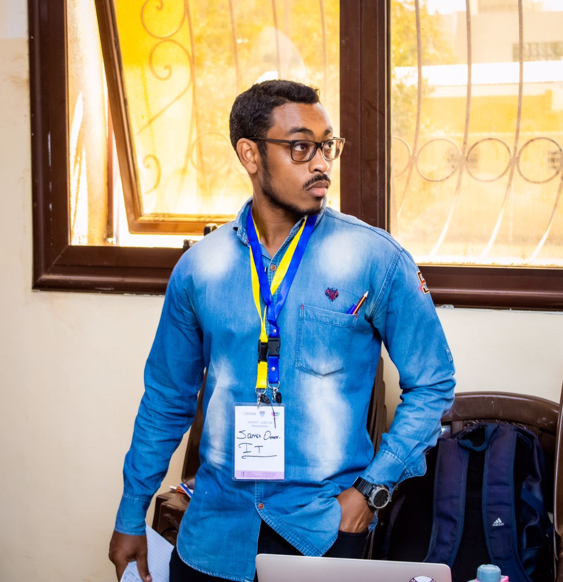
Contact

Address:
Omdurman – Al-Mohendseen – Block 29 , House No 414

Cell Phone:
+249963176158
Email:
samiromer2@yahoo.com
github:
https://github.com/samiromer2/
Personal Information

Nationality:
Sudanese.
Date of Birth:
11/12/1991
Place of Birth:
Almolazmen east
Marital Status:
Single

Employment and Experience
University of Karary /IT Consultant/6 -2018 till 4 -2019, Khartoum, Sudan.
Duties & Responsibilities:
- Maintain employee records.

Supporting health and wellness.

Offering continuing education.
- Advising management on the administration of human resources policies and procedures.
- Assisting with the development and coordination of recommended changes regarding workflow.
- computer maintenance
- Os maintenance (windows & Linux).
- installing windows, drives and basic office tools.
Comboni college, Teaching Assistant 06/2013 -02/2016, El Qasr Ave, Khartoum, Sudan
Duties & Responsibilities:
- Deliver tailored teaching activities to individual students or small groups of students
- Make sure that the students you are working with are able to engage in the learning at hand and stay on task
- Support the social and emotional development of students and report any issues when necessary
- Support the teacher in managing challenging student behaviour and promoting positive behaviour
- Guide and monitor student progress
- Help with the planning of some lessons
- Carry out administrative duties, such as preparing classroom resources
- Sharing stories to students about real tech life and the world.
- Provide support outside of the classroom
labs thought:
- Programming Languages.
- Programming II.
- Concept of Programming Language.
- Object-Oriented Programming.
- Micro - processor & Assembly.
- Computer Application.
- Computer Environment & Devices.
- Data Structure.
- Algorithm Analysis & Design.
- System Analysis & Design under DFD.
- System Analysis & Design under UML.

Samir Omer Ibrahim
Software Developer

Languages
Arabic: Native Language
English: Fluent, Advanced Reading and Writing
Italian: Fluent, Advanced Reading and Writing
Skill Highlights
- Leadership
- Project management
- Administrative skills
- Strong decision maker
Interest
- Wireless Sensors Network
- Foot ball
- Swimming
- Driving

- Introduction to Database.
- Advanced Database.
- Computer Network.
- Internet Technologies.
- Artificial Intelligence under Virtual Prolog.
Projects Superivated
- Chatting language converter using Android (Java).
- Nearest Petroleum Station using ArcGis.
Canadian Sudanese college, Teaching Assistant 11/2012 – 02/2014.
Duties & Responsibilities (labs thought):
- C /C++ /Java /Prolog /database /network (basic – advance) /data strucure /algorithm /Assembly /AI /Academic and Research Experience /Data Science /Applied Algorithms /Software Development /DevOps
- co-supervised many projects . (always control to deliver on time and )
Maglis Aldawa / Software Developer / 1 - 2013 till 6 - 2013, Al Mogtrebeen ,Khartoum, Sudan.
Duties & Responsibilities:

Developed system to manage and track the utilization of equipment.

Analyse and collect data to monitor business expenses and reduces operating costs.

Offer valuable data insights on business development.
Education
- Comboni College for Science and Technology/ B.Sc first of class – Distincition, Khartoum, Sudan
Certifications

Cisco Certified Network Associate (CCNA) at Kiwi training Center Jan - 19th -Feb 25th 2014.

Oracale SQL & developer/ C.L.I.K /1st -30th 2011.

Awards:
- Student projects:
- Arc-Gis 9.3 using python as an interface to use GIS tools to calculate the closest path.
- SAN integration with oracle using RAID. (under linux).Open data event open data hackathon 24 hours

Technical Skills
- Advanced knowledge HTML, PHP and JavaScript for web development.
- Laravel , Linux , data structures , algorithm desgin & analysis and Git
- C, C++,Java and python coding.-
- Great knowledge System Analysis & design (DFD &object oriented) and database overall.
- configuration for an Ubuntu server (NAS) used for file sharing with two users authentication .
Personal Skills
- Ability to lead others and collaborate in programming.
- Capable of working within Specific timeline and Deadlines.
- Ability to learn and implements new concept in programming.
- Ability to work under pressure.
- Team worker and Fast learner.
References
- Dr.Haitham A-Moniem,PHD Computer Science, Program Coordinator Comboni College of Computer Science and Technology, Lecturer in Comboni College of Computer Science and Technology, Khartoum, Sudan, tel: +2412613084, Email: a.hytham@hotmail.com
- Treacher. Mohammed Elnour Okasha, Lecturer in Faculty of Computer Sciences and Information Technology Alzaiem Alazhari University, Khartoum North, Lecturer in Comboni College of Computer Science and Technology,Khartoum, Sudan, tel: +249907173676,
Email: Mohakka222@gmail.com
- Amer Mohammed Easa, (Mobile Developer), Khartoum, Sudan, tel: +249922920765, +249904335656,
Email: Amromohamed755@gmail.com

